Duodenal Switch and SADI-S Vitamin Plan

Vitamin | Dose | Average Cost | Extra Information
Thompsons Vitamin A 10,000 IU  | 1 capsule daily  (Unless advised to take more) | $19.5 for 150 tablets  $3.90 per month | Vitamin A (as Retinyl Palmitate) - equiv. Retinol 3000 mcg  Online usually best price
Centrum Women 50 +  | 1 tablet daily | $23.95 for 90 tablets  $8 per month | Multivitamin – only  Online or in the supermarket
Calcium Citrate  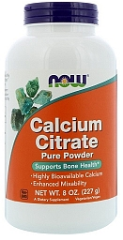 or 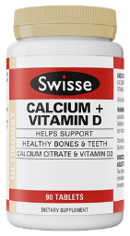 | 3 tsp powder daily  Or  4 tablets daily | Powder:  $15 per month  Or  Tablets:  $26 per month | Calcium Citrate  Online  *other calcium citrate products are available and can be used as long as you are getting 1200mg per day through just the calcium products
On Prescription - VitABDECK  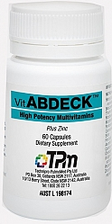 | 1 capsule twice daily | Subsidised on prescription. | Mix of readily absorbable fat soluble vitamins
On Prescription  Ferro-F-Tab (Iron) | 1 tablet twice daily  (Unless advised to take more) | Subsidised on prescription. | Iron (as ferrous fumarate)  Your bariatric surgeon, dietitian, or GP can complete this prescription
On Prescription  CalVit.D3 (Vitamin D) | 1 tablet every week  (Unless advised to take more) | Subsidised on prescription. | Vitamin D 50,000 units  Your bariatric surgeon, dietitian, or GP can complete this prescription
Hydroxocobalamin 1000mcg injection  Or  Solgar Vitamin B₁₂ 1000mcg chewable tablets | One injection every 3 months by IM injection  (Organise via GP) | Only needed if instructed by nurse | Vitamin B₁₂ 
You must start taking all of your vitamins and minerals at 1 week post-surgery (you must crush the tablets)

The top 3 items must be purchased before surgery. The average cost of the vitamins is approximately $26.90 - $37.90 - Some months may have a lower or higher cost due to bottles lasting longer than 1 month.

Iron (Ferro-F-Tab) must be taken 2hrs apart from anything with Calcium in it (milk / Calcium Citrate / Centrum)

Prescriptions will only be given during clinic – if your prescription runs out between appointments you MUST arrange a replacement via your GP

Do not get the Vitamin B12 injection unless advised by the surgeon / nurse specialist Thank you

